TRAFFIC SIGN DETECTION AND Recognition USING MATLAB

Jonathan Ifegunni

School of Electrical and Computer Engineering

University of Oklahoma
Norman, OK 73019-1023, USA

Abstract

The main purpose of this paper is to use basic image processing technique to detect and recognize Traffic signs. Traffic signs are designed such that they can be easily observed by humans because of their shape and shading which are not precisely the same as surrounding environment. MATLAB Image Processing toolbox is used in this project. This project employs the use of Maximally Stable Extremal Regions (MSER) as basic letter or sign candidates. These candidates are then filtered using geometric and stroke width information to exclude non-text or sign objects and finally relaying them to the driver. Work also must be done with the robustness of the system, because time is of the essence while driving and the faster the information is provided, the more time the driver must react to the surroundings

1. Introduction
Traffic signs are crucial for safety on the road. They let the drivers know how fast to drive, when and where to turn or not to turn. However, Traffic sign detection and recognition is a big issue in autonomous Vehicles and drivers supports systems [1]. Using MSER, CC and Stroke Width algorithm we could read and display the correct info to the driver without much distraction.
Warning, Prohibition, Obligation and Informative are the four different types of traffic signs in the traffic code. Based on the shape and color, the warning signs are equilateral triangles with one vertex at the top. Prohibition signs are circular with distinct figure in each case over a white or blue background or a red border. Circular signs with a figure over a blue background indicate obligation [2].
There are 2 main phases to Traffic Sign Recognition, traffic sign detection and classification [3]. The main challenge in the detection phase is finding a way to take out all the non-sign objects in the picture while keeping the signs in the picture without any distortion. The task of recognition phase is to take these detected signs and recognize them keeping in mind the end goal to give relevant information to the user.
Using Maximally Stable Extremal Region (MSER), Connected Component (CC), and the Stroke Width Algorithm, we could read, discriminate between sign and background in an image, and relay (visually or audio) to an autonomous vehicle system or to a driver (without distraction).
MSER is a natural choice for region detection and can be used to discriminate between the traffic sign and the background. Unfortunately, due its robustness against view, scale and lighting changes, it is sensitive to image blur. Other image processing procedures for detecting a sign includes [3]:
- Geometric Filtering
- Finding Stroke Width
- Text Line Formation
- Word Separation

2. BACKGROUND
There are several other works done by various scholars using CC and MSER algorithm for discriminating between text and non-text element in an image.
[3] Huizhong Chen proposed a novel CC-based text detection algorithm, which employs Maximally Stable Extremal Regions (MSER) as his basic letter candidates. Despite its favorable properties, MSER has been reported to be sensitive to image blur. As opposed to texture-based methods, the CC-based approach extracts regions from the image and uses geometric constraints to rule out non-text candidates. The top scoring contestant applies an adaptive binarization method to find CCs. Text lines are then formed by linking the CCs based on geometric properties. With the extraction of edge enhanced MSER, he obtained a binary image where the foreground CCs are considered as letter candidates. Like with most state-of-the-art text detection systems, he performed a set of simple and flexible geometric checks on each CCs to filter out non-text objects.
[4] Gonzalez Alvaro proposed a new method to locate text in images with complex background. It efficiently combines MSER and a locally adaptive thresholding method. The result is a connected-component-based approach that extracts basic letter candidates using a series of easy and fast-to-compute features. These features, after having been extracted from a challenging train dataset which contains different texts in a huge variety of situations, have proved to follow a Gaussian distribution. It means that they can be used with any dataset independently from their color, font or size. Actually, the proposed method has been tested on four different test datasets and the achieved results show the competitiveness of the method. Unlike other methods, a strong point is the use of feedback in order to restore those characters that might have been filtered out erroneously after computing the text features for each letter candidate. It has been also proposed to use a classifier based on simple features such as mean, standard deviation and HOG computed over image blocks in order to remove repeating structures that can be easily confused to text lines, such as bricks or fences.
There are several geometric properties that are good for discriminating between text and non-text regions [4], including:
a. Aspect ratio
b. Eccentricity
c. Euler number
d. Extent
e. solidity

[5] Li, Yao, and Huchuan Lu proposed another common metric used to discriminate between text and non-text, Stroke Width. Stroke Width is a measure of the width of the curves and lines that make up a character. Text regions tend to have little stroke width variation, whereas non-text regions tend to have larger variations. To help understand how the stroke width can be used to remove non-text regions, estimate the stroke width of one of the detected MSER regions. You can do this by using a distance transform and binary thinning operation.
However, this project modifies and leverages the techniques used for text detection in Images and applies it to Traffic Sign Detection.

3. structure of the algorithm
1. Text Region Detection Using MSER:
These approach works best with images with consistent color and high contrast of text leads to stable intensity profiles. The MSER feature detector works well for finding text regions.
MATLAB has a function called the “detectMSERFeatures” function to find all the regions within the image and displays the result these results. This feature is not 100% perfect as there are many non-text regions detected alongside the text. [3].
Removal of non-text region
Two method were applied in the removal non-text region. Stroke width variation and a rule-based approach for removing non text region were methods applied to remove non-text region.

2. Non-Text Regions Removal using Geometric Properties
While detecting text, the MSER also detects many other regions in the image that are not text. To compensate for this limitation, geometric properties of text can be used to filter out non-text regions using simple thresholds. A far more supplicated approach is the use of convolutional neural network for detection. However, combining the two approaches produces better results [6]. This example uses a simple rule-based approach to filter non-text regions based on geometric properties.
The MATLAB function “regionprops” was used to measure a few of these properties like Aspect ratio, Eccentricity, Solidity, Extent, Euler Number. and then remove regions based on their property values [3] [4].

3. Non-Text Regions Removal Using Stroke Width Variation
This is used to discriminate between text and non-text is stroke width. It is a measure of the width of the curves and lines that make up a character. Text regions tend to have little stroke width variation, whereas non-text regions tend to have larger variations.
To help understand how the stroke width can be used to remove non-text regions, estimate the stroke width of one of the detected MSER regions. You can do this by using a distance transform and binary thinning operation [3].

4. Merge Text Regions and Text Recognition using OCR
The approach used in this project for merging individual text regions characters, was to create a bounding box around characters in neighboring regions. To find neighboring regions, expand the bounding boxes computed earlier with “regionprops”. This makes the bounding boxes of neighboring text regions overlap such that text regions that are part of the same word or text line form a chain of overlapping bounding boxes.
Bounding boxes that overlap can be merged together to form a single bounding box around individual words or text lines. To do this, compute the overlap ratio between all bounding box pairs. This quantifies the distance between all pairs of text regions so that it is possible to find groups of neighboring text regions by looking for non-zero overlap ratios. Once the pair-wise overlap ratios are computed, use a “graph” to find all the text regions "connected" by a non-zero overlap ratio.
Use the “bboxOverlapRatio” function to compute the pair-wise overlap ratios for all the expanded bounding boxes, then use “graph” to find all the connected regions.
The detected results are composed of individual text character, to enable recognition of actual words that carry more meaningful information than just the individual characters, the recognition phase of this project was carried out using the MATLAB feature “ocr”, the individual text characters must be merged into words or text lines. For example, recognizing the string 'STOP' vs. the set of individual characters {'T','S','P','O'}, where the meaning of the word is lost without the correct ordering.

4. RESULTS

Using the MSER, the system was able to read the text from the signs. Simple traffic sign for example STOP sign were easy to read, and intelligence was generated from the result; but as the image got complicated, the system wasn’t able to completely make sense of what of the text. Hence, with the implementation of CCs and Stroke Width algorithm I could be able to read the text as is and display it to the driver. The following were result gotten with MSER text detector:

Test case 1:
The first case is the STOP sign which is used at most intersection. Failure to adhere to this sign would lead collision. The MSER text detector worked perfectly for the first image below and was able to read the image properly and separate the text from the background. All the area of the traffic sign is detected and all the text on the road sign is read. In the correct order as well.

Image detected:

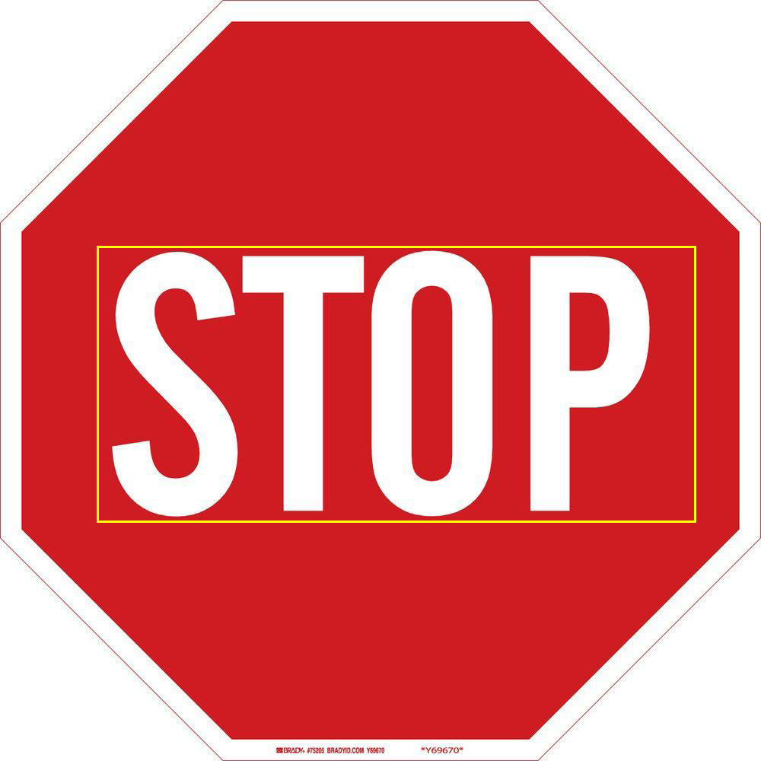
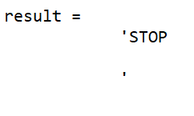
Test Case 2:
This is a collection of traffic signs in one image. The aim of this test was to test determine how effective the system was. Given a group of traffic signs in one image, can the system detect every text in the image and group the text in the right way to provide intelligence for the driver.

Fig 2:
- Image detected

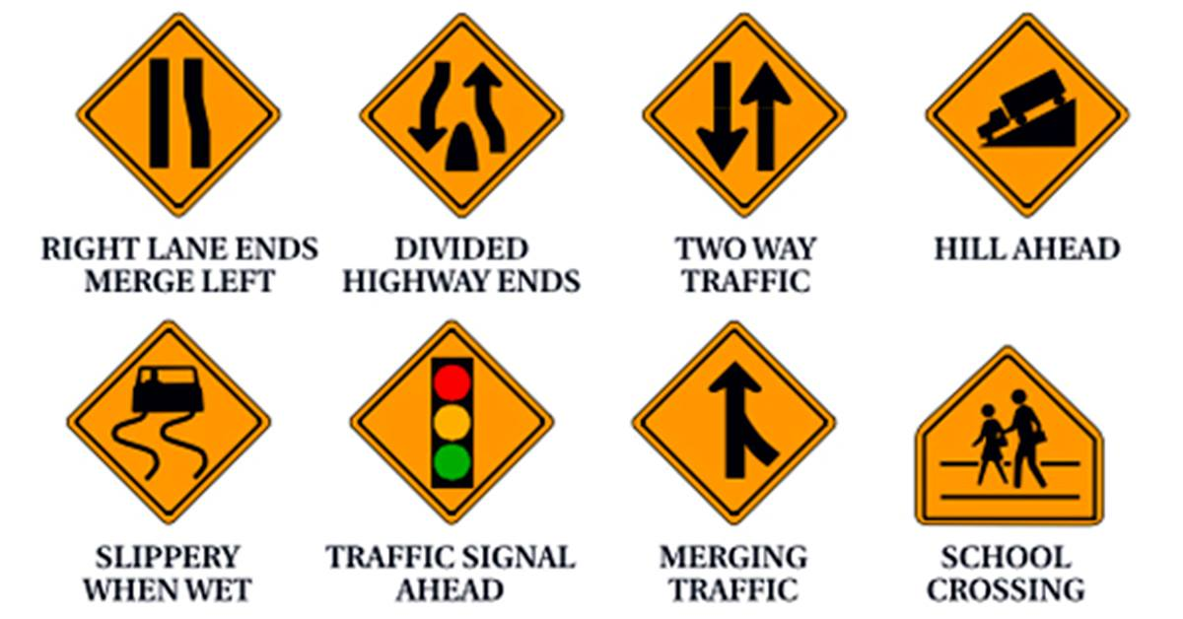

b)

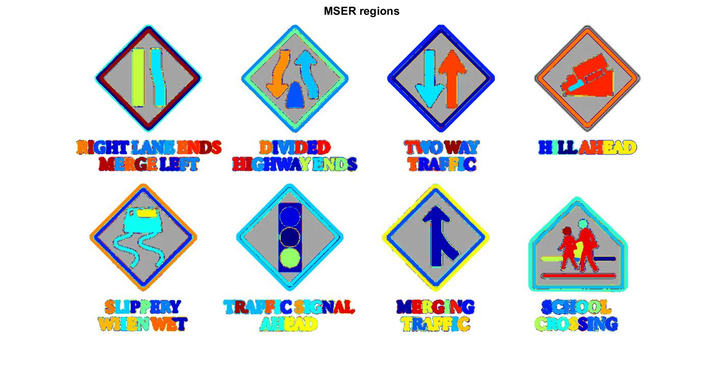
c)

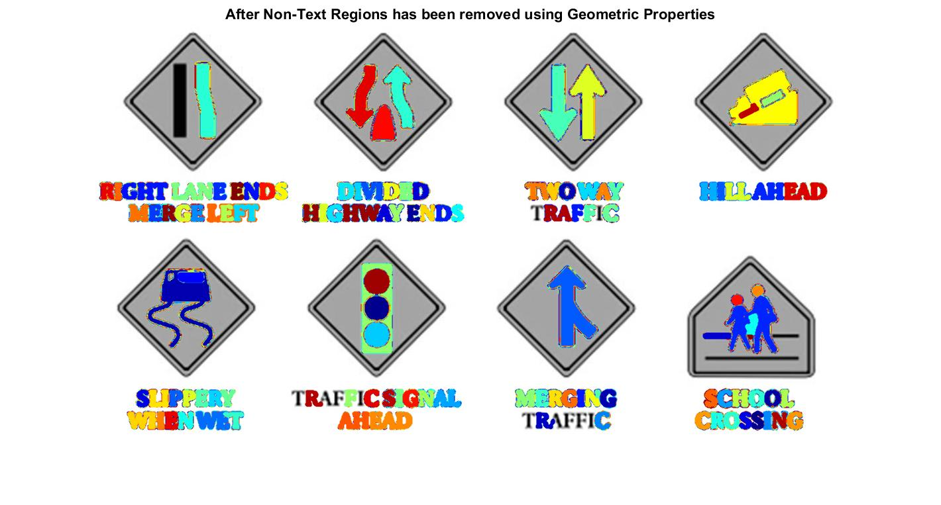
d)

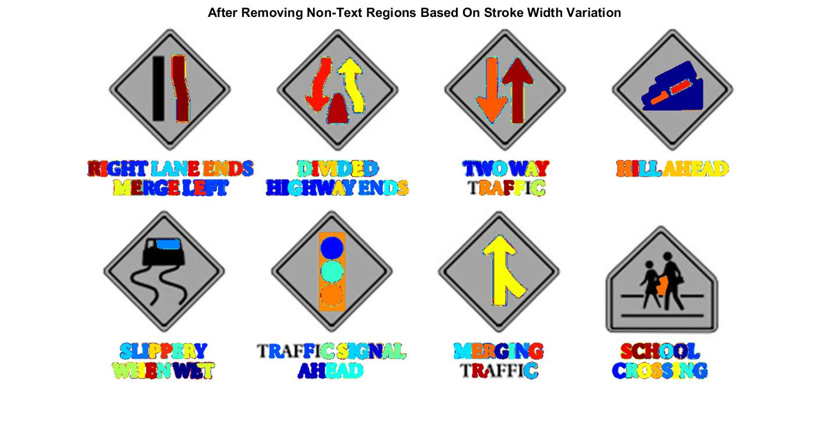
e)

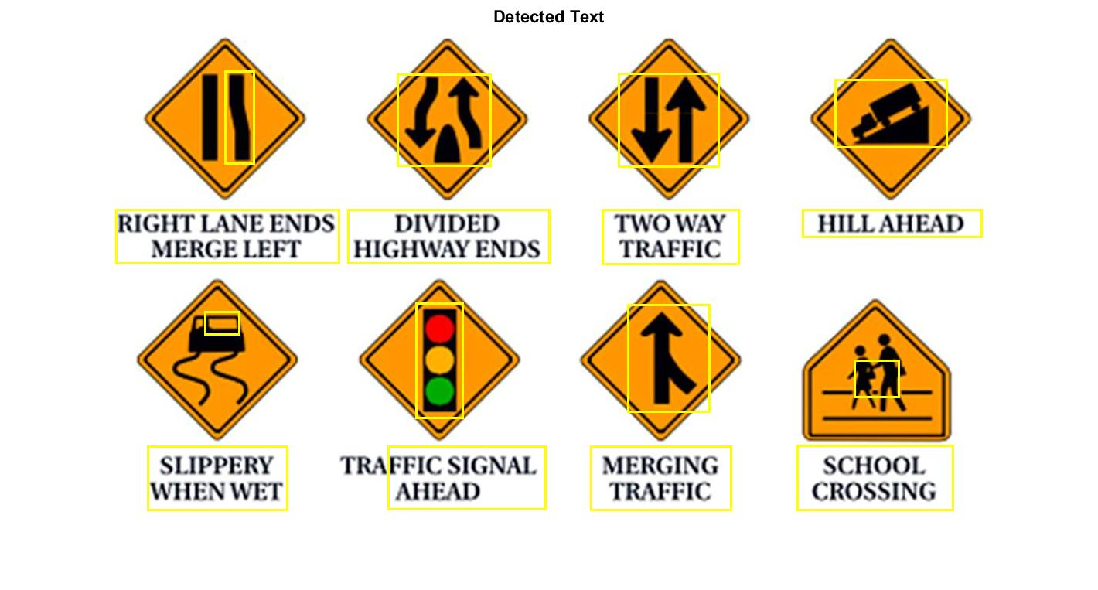

f)

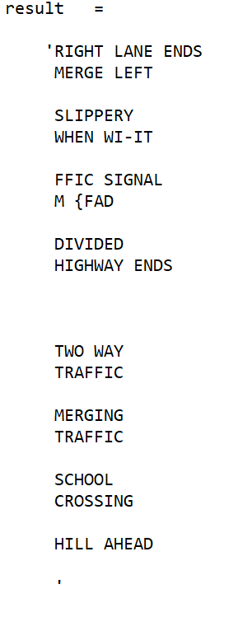
Fig 2 a – e) shows the various operations on the image and its result. Fig 2b) shows the result of the MSER feature detector used for detecting text in the image in fig 2a). fig 2c) and fig 2d) show the aftermath of the discrimination between the text and the background using both geometric properties and stroke width algorithm, the signs “TRAFFIC SIGNAL AHEAD” and” SLIPPERY WHEN WET” signs were not properly read. Fig 2f) shows the result after all the operations have been carried out on the image. The code read the images but failed to produce the right text in the 2 of the images. Instead of signs “TRAFFIC SIGNAL AHEAD” and” SLIPPERY WHEN WET” the system produces “FFIC SIGNAL M {FAD” and “SLIPPERY WHEN WI-IT”. This would most definitely confuse the driver and might lead to an accident.

Test Case 3:

Fig 3a – b)
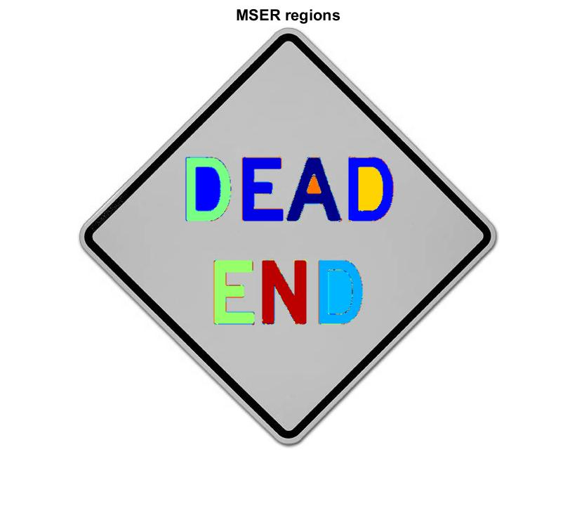
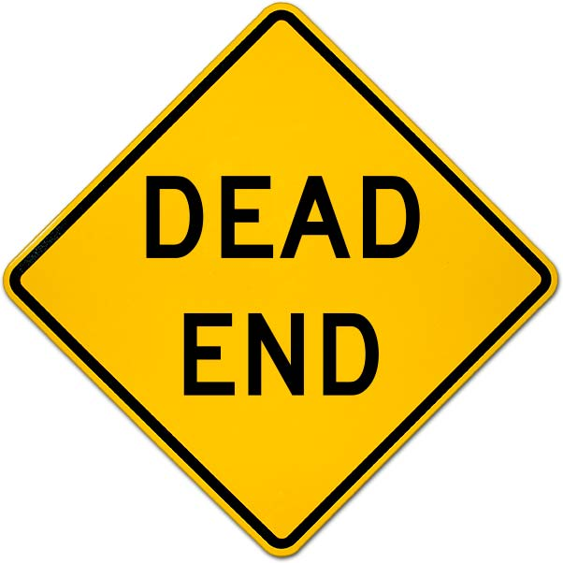

Fig 3 c – d)
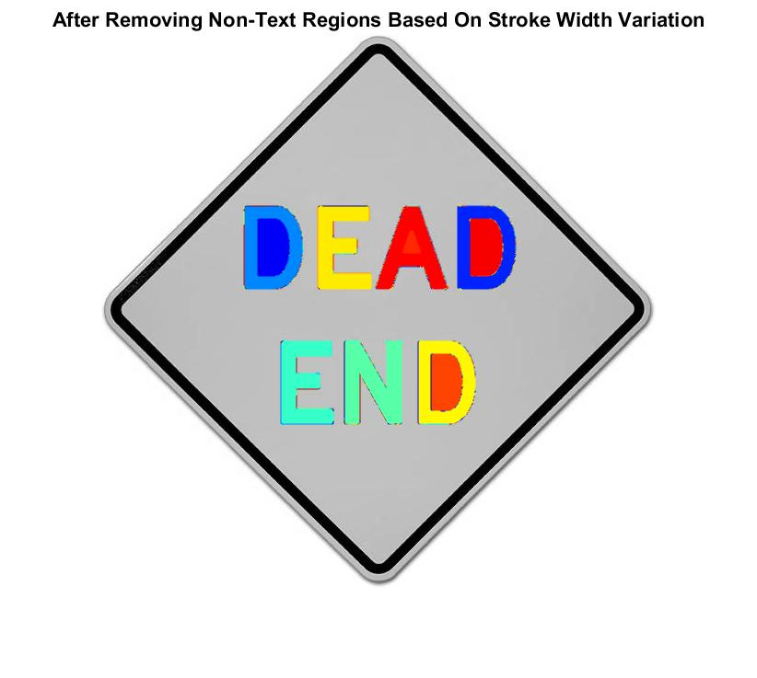
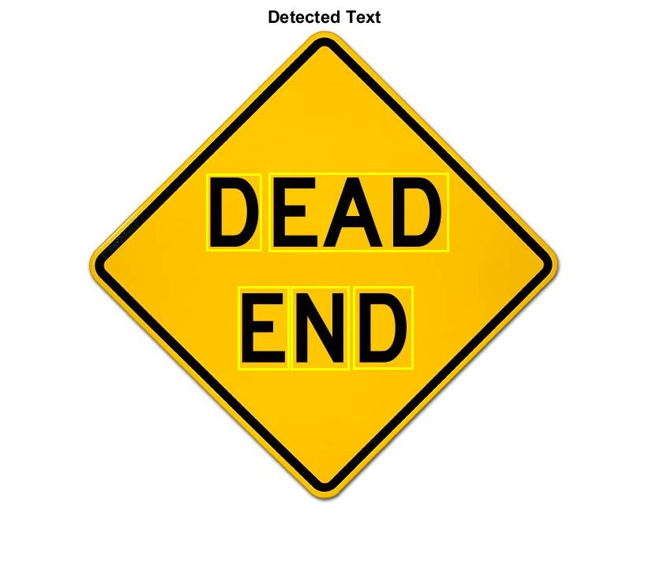
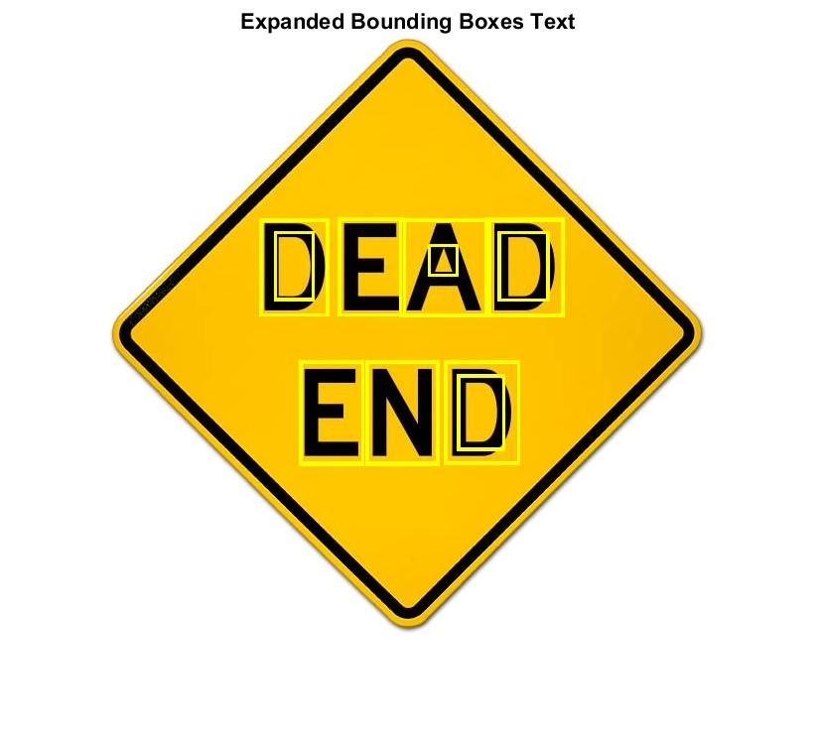
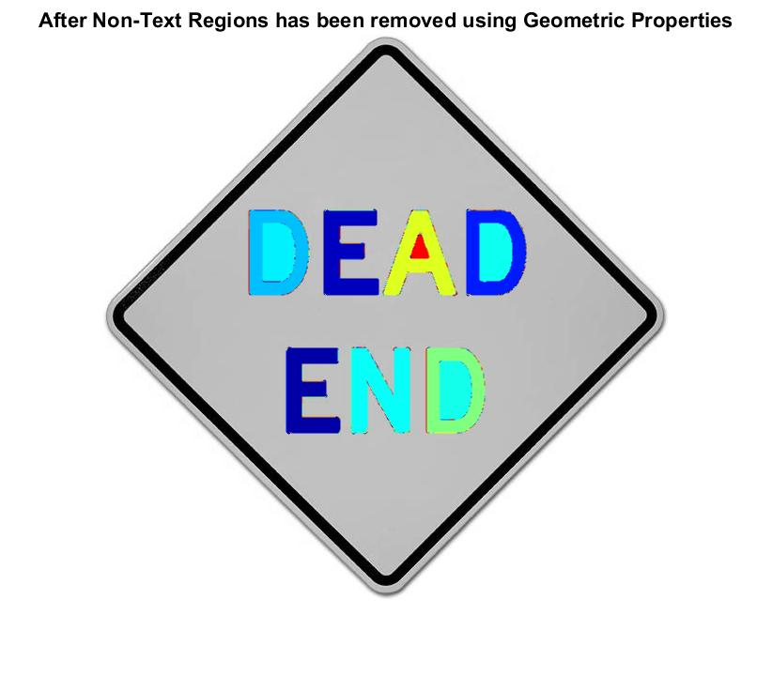

Fig 3 e – f)

Fig 3 g)
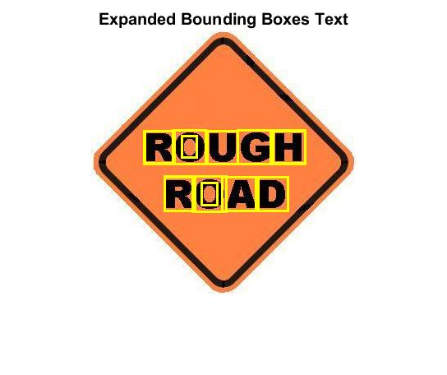
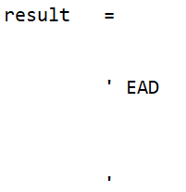

Fig 3 a – e) also shows the various operations on the image and its result. Fig 3b) shows the result of the MSER feature detector used for detecting text in the image in fig 3a). fig 3c) and fig 2d) show the aftermath of the discrimination between the text and the background using both geometric properties and stroke width algorithm, the signs were not properly read. Fig 3f) shows the how the text was detected after all the operations have been carried out on the image. The code read the image but failed to produce the right text in the images. Instead of sign “DEAD END” the system produced “EAD” as shown in the screenshot in fig 3g). This indicated that the system is definitely not efficient enough This would most definitely confuse the driver and might lead to an accident.
However, it failed to read the image below correctly and looking at the result, we can see errors in the way the image is read.

Test 4:

Fig 4 a, b)
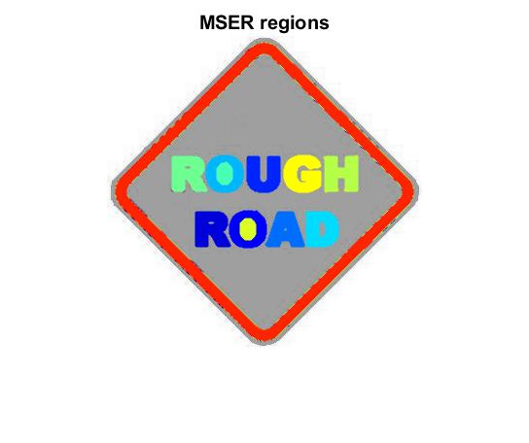
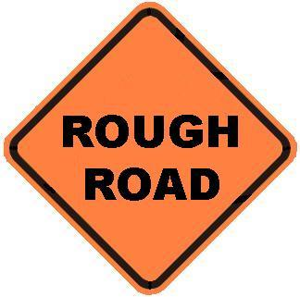

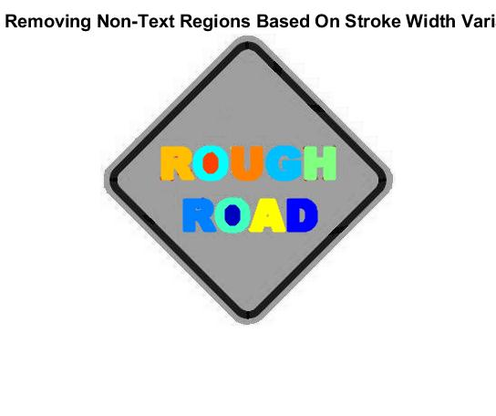
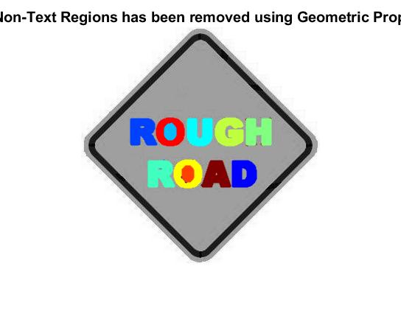
Fig 4 c, d)

Fig 4 e, f)

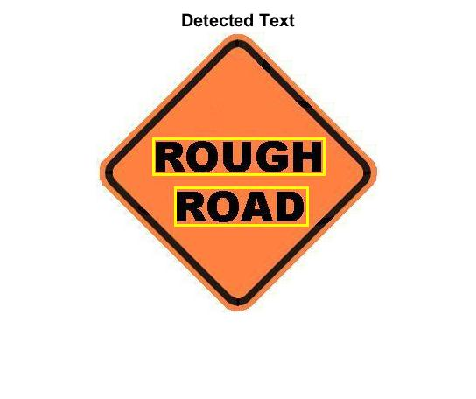
Fig 4 g)

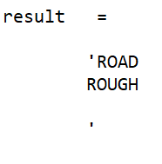
Fig 4 a – e) shows the various operations on the image and its result. Fig 4b) shows the result of the MSER feature detector used for detecting text in the image in fig 4a). fig 4c) and fig 4d) show the aftermath of the discrimination between the text and the background using both geometric properties and stroke width algorithm, Fig 4f) shows the result after all the operations have been carried out on the image. The code detected the texts in the image but failed to produce the words in the right order. Instead of sign “ROUGH ROAD” the system produces “ROAD ROUGH”. This would most definitely confuse the driver as the system will be expected to provide the right information to the driver.

Test 5:
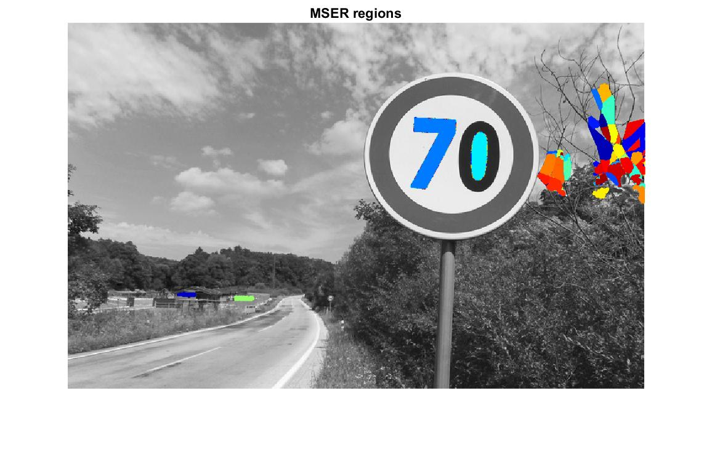
Fig a, b)
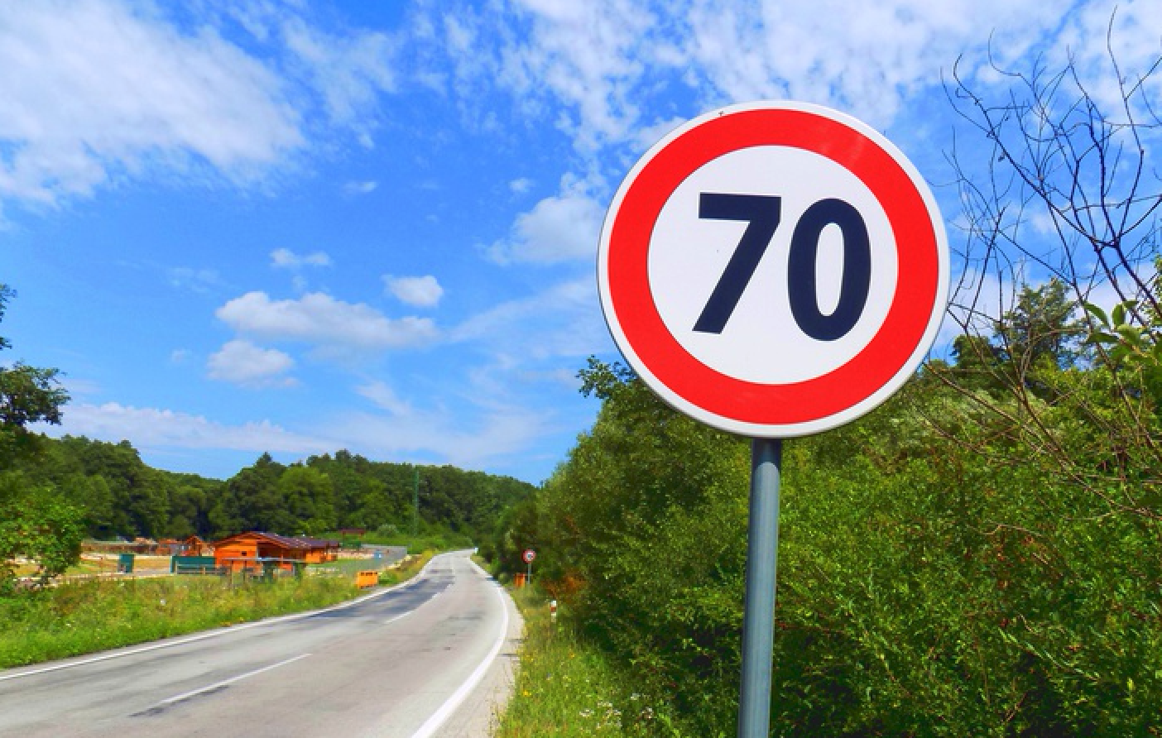

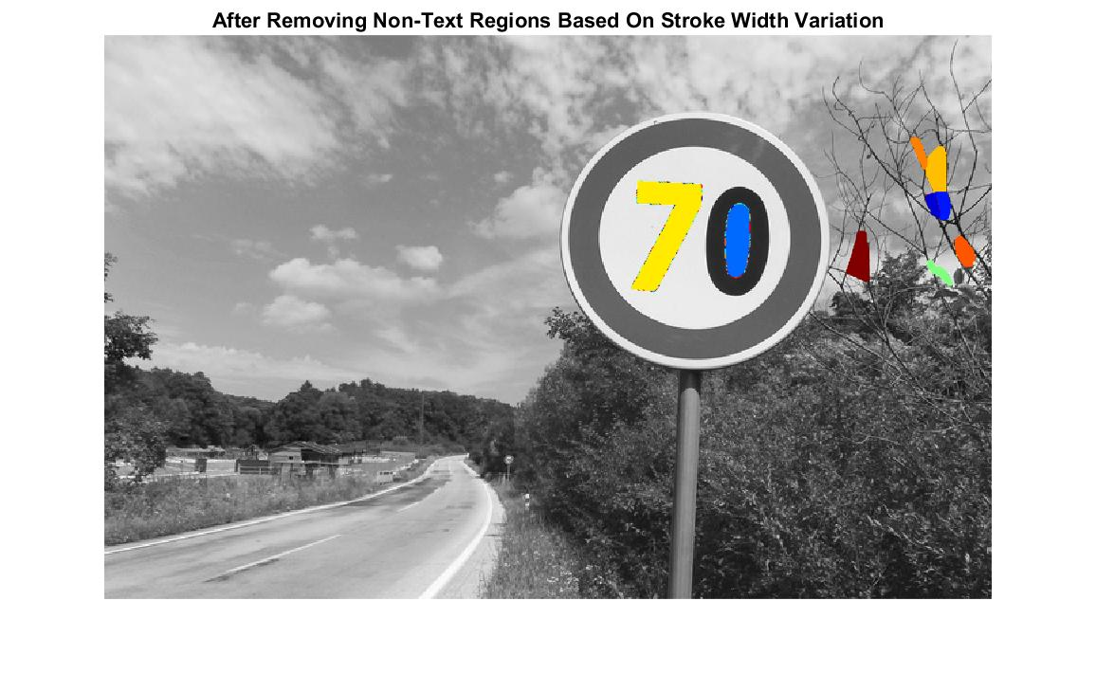
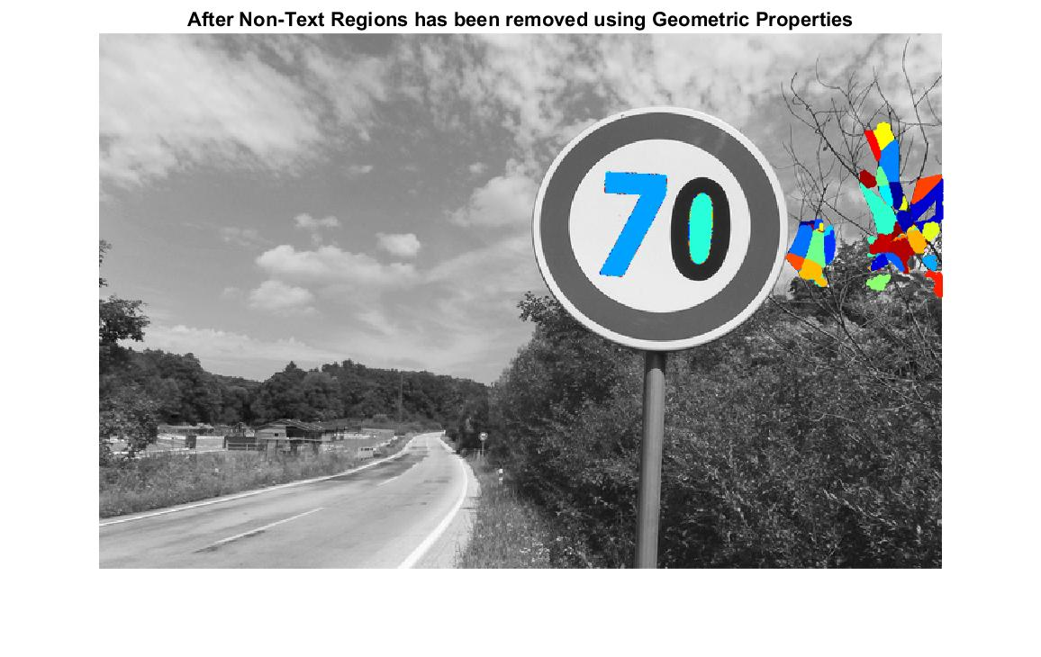
fig c, d)
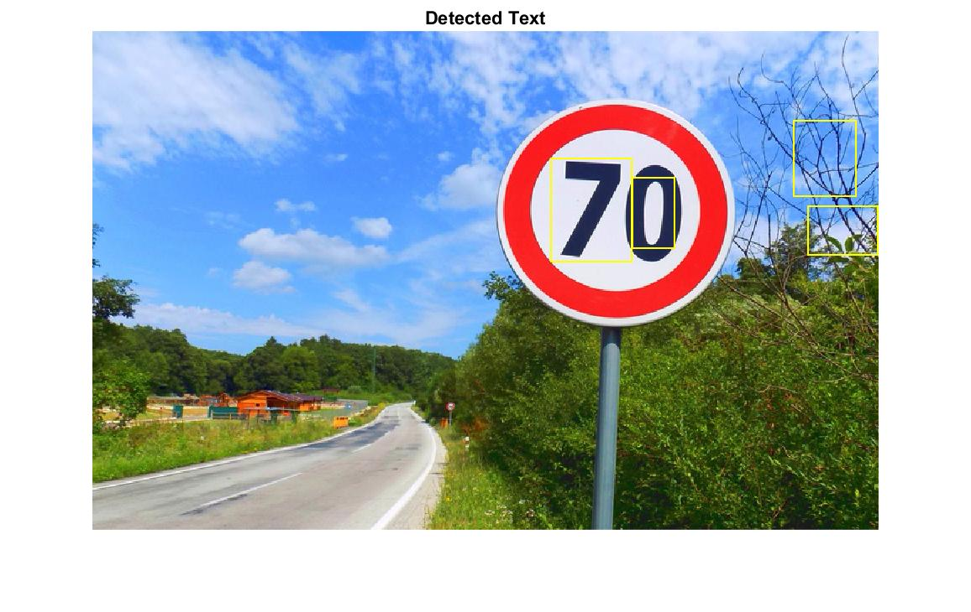
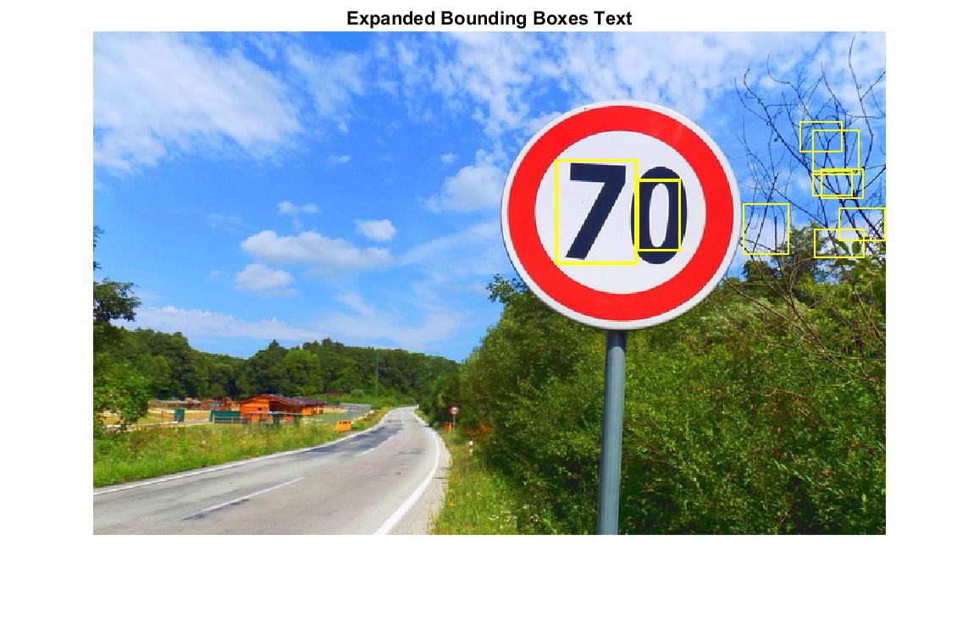
fig e, f)
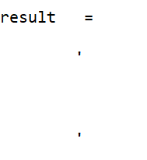
Fig 5 a – e) shows the various operations on the traffic sign with its environment in the background and its result. Fig 5b) shows the result of the MSER feature detector used for detecting text in the image in fig 5a), this failed to differentiate between the sign and its environment in the background. fig 5 c) and fig 5 d) show the aftermath of the discrimination between the text and the background using both geometric properties and stroke width algorithm, Fig 5 f) shows the result after all the operations have been carried out on the image and how the system analysis the image, the bounded box is used to indicate areas considered as text in the image. There are boxes in the tree which means that the code failed to discriminate the background.

6. CONCLUSIONS

From the above result, it can be seen that the proposed approach works but not for all scenarios. The code base still needs to be worked on to get optimal result from all image regardless of background. This is to prevent errors while reading signs like mistaking one sign for the another or displaying wrong information on the dashboard confusing the driver which might lead to an accident in the worst case.
The system was tested with images of various background. Testing with images with single background like in Test 1- 4. These images were just the traffic sign itself without it surrounding in the background. The system detected all texts in the images, and the result was correct in most cases. However, testing the code with other images with its surrounding in the background, like test 4-5, it became evident that all the conditions of the backgrounds, size of the road sign, surrounding colors needs to be considered.
The code needs to be modified to take account of various factors especially external surrounding. Since image the system would read would be real-time, real-world image, the system is expected to differentiate not the text on the traffic sign from its background but also its surrounding background captured by its camera

6. References

[1] Mohit Bhairav Mahatme; Mrs. Sonia Kuwelkar. “Detection and recognition of traffic signs based on RGB to red conversion” 2017 International Conference on Computing Methodologies and Communication (ICCMC), 2017 18th July IEEE International Conference on. IEEE, 2017.

[2] M. A Garcia, M. A Sotelo, and E. M Gorostiza, “JPEG 2000: Traffic Sign Detection in Static Images using Matlab” in Conference on Emerging Technologies and Factory Automation. Proceedings 2003.

[3] Chen, Huizhong, et al. "Robust Text Detection in Natural Images with Edge-Enhanced Maximally Stable Extremal Regions." Image Processing (ICIP), 2011 18th IEEE International Conference on. IEEE, 2011.

[4] Gonzalez, Alvaro, et al. "Text location in complex images." Pattern Recognition (ICPR), 2012 21st International Conference on. IEEE, 2012.

[5] Li, Yao, and Huchuan Lu. "Scene text detection via stroke width." Pattern Recognition (ICPR), 2012 21st International Conference on. IEEE,2012.

[6] Neumann, L.a. (2012). Real-time scene text localization and recognition. Computer vision and pattern Recognition (CVPR), 2012 IEEE Conference on. IEEE 2012.

.

